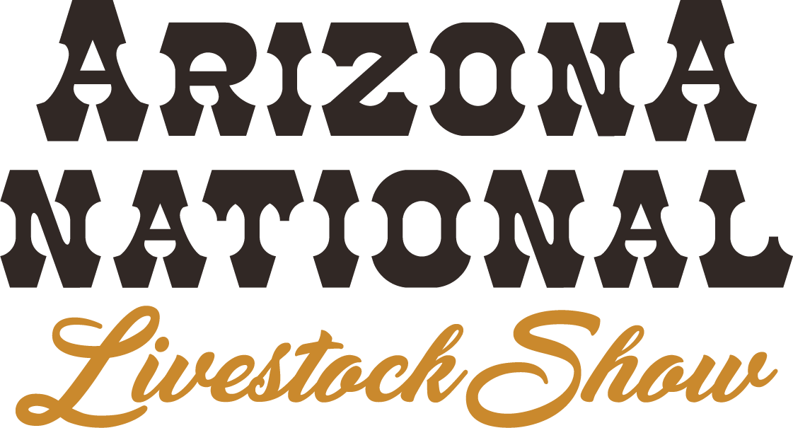
2021 results
Prospect/progress steer
Judge: Dave Allan, Nocona, TX
December 29, 2021

Champion Prospect – entry 4541 – Elizabeth Norwood, Midlothian, TX – 755 lbs.
Reserve Prospect – entry 5415 – Lexi Hill, Mack, CO - 777 lbs.
Best Arizona – entry 247 – Grace Groseta, Cottonwood, CA – 955 lbs.
2nd Best Arizona – entry 4442 - Tyler Pouquette, Flagstaff, AZ – 775 lbs.

Champion Progress – entry 365 – Tyler Ganser, Yuma, AZ - 1450 lbs.
Reserve Progress – entry 4670 – Kloey Dugan, Stanfield, AZ - 1290 lbs.
Best Arizona – entry 365 – Tyler Ganser, Yuma, AZ – 1450 lbs.
2nd Best Arizona – entry 4670 – Kloey Dugan, Stanfield, AZ – 1290 lbs.

